
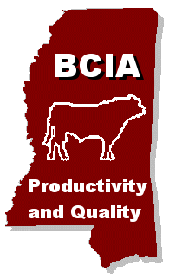
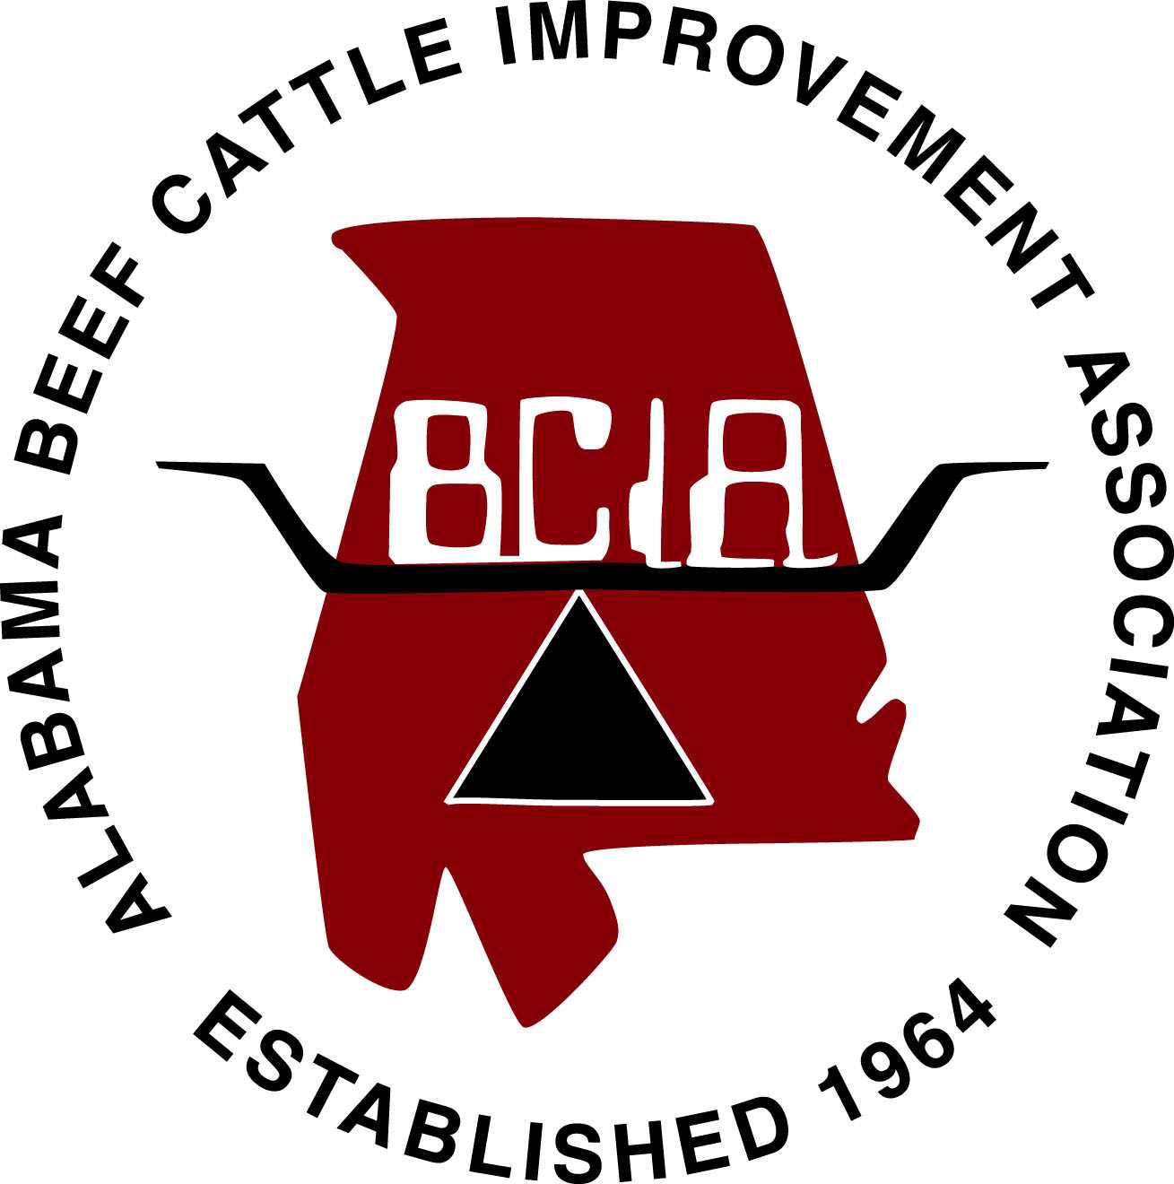
Beef Cattle Nutrition Short Course

Nutrition Short Course
Registration Form
Name:
Address:

Phone:
Number Attending:
*Preferred Site:
Registration Fee Enclosed: $
(Registration is $50 per person for entire series or $15.00/night)

Please make checks payable to Nutrition Short Course and send along with registration form to:

Nutrition Short Course – Louisiana
Please return registration form to your local county agent

Nutrition Short Course – Mississippi
Box 9815, Mississippi State, MS 39762

Nutrition Short Course – Alabama
209 Animal Sciences
Auburn, AL 36849

Nutrition Short Course – Florida
Dept of ANSC – Bldg 459 Shealy Dr.
PO Box 110910, Gainesville, FL 32611-0910

Louisiana
Jason Rowntree
Phone: (225) 578-3345
E-mail: jrowntree@agcenter.lsu.edu

Mississippi
Jane Parish
Phone: (662) 325-7466
E-mail: jparish@ads.msstate.edu

Alabama
Lisa Kriese-Anderson
Phone: (334) 844-1561
E-mail: kriesla@auburn.edu
http://www.aces.edu/animalforage/ (on-line registration)

Florida
Matt Hersom
Phone: (352) 392-2390
E-mail: hersom@animal.ufl.edu

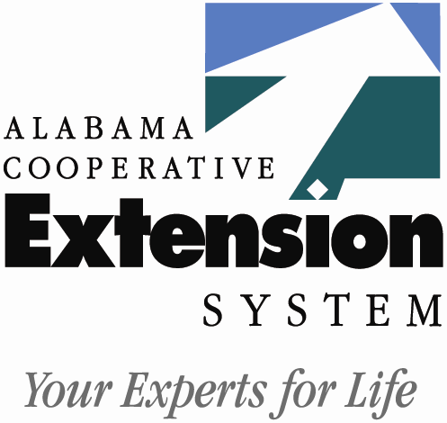



Beef Cattle Nutrition
Series
2007 Schedule

Applied Tools for Efficient Production

Hosted over interactive video at sites throughout Louisiana, Mississippi, Alabama and Florida Check the schedule for details and times.
Issued in furtherance of Cooperative Extension work, Acts of Congress of May 8 and June 30, 1914, in cooperation with the United States Department of Agriculture. The Louisiana Cooperative Extension Service provides equal opportunities in programs and employment.

Mississippi State University does not discriminate on the basis of race, color, religion, national origin, sex, sexual orientation or group affiliation, age, disability, or veteran status.

Alabama A&M and Auburn Universities, and Tuskegee University, County Governing Bodies and USDA Cooperating. The Alabama Cooperative Extension System offers educational programs, materials, and equal opportunity employment to all people without regard to race, color, national origin, religion, sex, age, veteran status or disability.

* For information on participating distance education sites or other short course questions contact your local Extension office or contact the person listed on the registration form under your particular state.

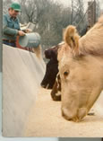
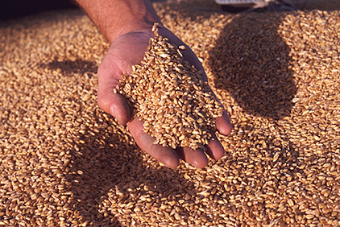

OCTOBER 30TH 5:45-8 PM
Commodity Feeds in Detail

- Feeding Distiller’s grains
- commodity feed supplementation

SEPTEMBER 25TH 6:45-9 PM
Weaned Calf Development and Economics
- Weaned calf nutrition
- minerals and feed additives
- backgrounding / stocker gost of gain

JULY 31ST 6:45-9 PM
Assessing Cattle
Nutrition Needs
and Feed Sources
- Opening and Nutritional Needs
- Forage availability
- hay feeding calculations
- introduction to commodity feeds

AUGUST 28TH 6:45-9 PM
Reducing Stored Feed Needs
- Winter pasture planning
- Legumes in Southern pastures
- forage utilization and grazing methods
NOVEMBER 27TH 5:45-8 PM
Applied Nutrition Tools
- Heifer and bull development
- cowculator and stocker ration balancers

Beef Cattle Nutrition Series

